**Resume**

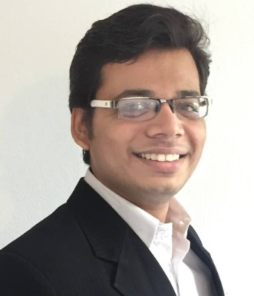**Personal Details**

Name Prithvi Prakashkumar Patel

Address Vogteistrasse 5,

88250 Weingarten

Mobile +4917640445531

E-Mail prithvi14091996@gmail.com

DOB/POB 14.09.1996 / Ahmedabad, India

Nationality Indian

**Education**

**Since 08/2020 M.E., Electrical and Embedded Systems**

Focus AI, Computer Vision, Automotive Systems

Hochschule Ravensburg Weingarten

Weingarten, 88250 Deutschland

**03/2016 – 08/2020 B.E., Electrical and Information Technology**

Focus Automation Technology, Networking

Hochschule Ravensburg Weingarten

Weingarten, 88250 Deutschland

**Experience**

**04/2020 - Now** **Master Thesis: Analysis and evaluation of the need of generic and scalable Cloud-based OTA update system**

* Design of a new generic and scalable architecture for OTA updates, which can be applied to various sectors

Soluware GmbH, Ravensburg

**02/2020 – 02/2022** **Working Student - Software Engineer**

* Xamarin Apps, WPF apps and backend development in .NET framework and .NET core
* Test Automation, Code Refactoring, Debugging and Building Tools

Soluware GmbH, Ravensburg

**Hands-on Projects**

**12/2021 – 02/2022 AkaFLASH tool (Company Project)**

* Backend Web API, which processes user/configuration data and stores/retrieves from/to database. Used Dot NET framework, C# for the Backend API, WPF as Client app and MySQL for the phpMyAdmin Database. Chain of Responsibility Design Pattern used and dependency injection for API call.

**03/2021 – 08/2021** **Womega E-Commerce Full Stack Web App**

* Full Stack Ecommerce WebApp that allows customers to browse through clothes, add them to cart and pay with credit/debit cards. This project includes an admin portal to maintain products, company analytics and perform business activities. Dot NET Core for Backend, HTML, Bulma CSS and VueJs for Frontend and local database. Chain of Responsibility Design Pattern used, Layered (N-Tier) Architecture and essence of Service Oriented Architecture (SOA) for API methods

GitHub: <https://bit.ly/3mAld4p>

**05/2021 – 06/2021** **Requirement Parser**

* WPF helper desktop application for analyzing functional and non-functional requirements and generating CAPL-testcases for software testers. Used C#, WPF Dot NET framework. I implement recursive binary search tree data structure for parse the requirement document as CSV file.

GitHub: <https://bit.ly/3zsOLso>

**Technical skills**

**Skills**  C, C++ for Graphics and Embedded programming,

JAVA – Android Studio, Swing, Linux command line, Git and Gitlab for version control, Meld

C# for Xamarin, WPF und Web API .Net Framework, und .Net Core MVC – MVVM Web Application, C++, Python (ROS), VueJs (JavaScript) and LINQ

Software IDE Code: Blocks, NetBeans IDE, Eclipse IDE, Design Suite,

Atom IDE, Microsoft Office: Word, PowerPoint, Excel und Access, AutoCAD 2015 mit Autodesk Professional Certificate,

Visual Paradigm UML-Tool, Visual Studio., C#, Android Studio, Visual Studio Code

**Languages**

German Good Knowledge (B2)  
English Fluent in speaking and writing   
Gujarati Native

**Hobbies and Leisure activities**

Indie Game Developer, Listening Music, Book Reading

Weingarten, 24.06.2022

Prithvi Patel